|  |
| --- |
| EPAM Systems, RD Dep.  MTN.*NIX.07 Oracle DB. Introduction to DWH |
| MTN.*NIX.07 Labs - Dimension and Facts Basics |

|  |  |  |  |  |  |
| --- | --- | --- | --- | --- | --- |
| REVISION HISTORY | | | | | |
| Ver. | Description of Change | Author | Date | Approved | |
| Name | Effective Date |
| 1.0 | Initial status of document | [**Kiryl Bucha**](mailto:Kiryl_bucha@epam.com) | 16-JAN-2012 |  |  |
|  |  |  |  |  |  |

*Contents*

1. Prerequisites Task 3

1.1. Passwords Index 3

1.2. Folder Paths Index 3

2. Create and populate Dimension of TIME DW – Layer 3

2.1. Task 01: CREATE DW.T_DAYS 3

2.2. Task 02: CREATE DW.T_WEEKS 4

2.3. Task 03: CREATE DW.T_MONTHS 4

2.4. Task 04: CREATE DW.T_QUARTERS 4

2.5. Task 05: CREATE DW.T_YEARS 4

3. OLAP – Business analyses task 4

3.1. Task 06 – Solution concept – Add: Chapter Dimensions Types 4

3.2. Task 07 – Solution concept – Add: Chapter Dimensions Hierarchies 5

3.3. Task 08 – Solution concept – Add: Chapter Facts Aggregations 6

# Prerequisites Task

## Passwords Index

|  |  |  |
| --- | --- | --- |
| Password Group | Login Name | Password |
| Operation System | root | “rootadmin” |
|  | oracle | “oracleadmin” |
|  |  |  |
| Oracle System | sys | “sysadmin” |
|  | system | “sysadmin” |
|  |  |  |
| Oracle Users | All DB users | “%PWD%” |
|  |  |  |
|  |  |  |

## Folder Paths Index

|  |  |  |
| --- | --- | --- |
| Path Group | Path Description | Path |
| Operation System | Oracle RDBMS – BIN | /oracle/app/oracle |
|  | Oracle Inventory | /oracle/app/oraInventory |
|  | Oracle Database Storage | /oracle/oradata |
|  | Oracle Install Directory | /oracle/install |
| Oracle | ORACLE_BASE | /oracle/app/oracle |
|  | ORACLE_HOME | $ORACLE_BASE/product/11.2 |
|  |  |  |
| FTP | ftp Incoming Folder | **/ftp/incoming** |
|  |  |  |
|  |  |  |

# Create and populate Dimension of TIME DW – Layer

**Notes:**

To Populate Time dims use External Resources:

|  |  |
| --- | --- |
| File Name | Path |
| Calendars.sql | … \Topic 07 - Dimension and Facts Basics\LabScripts\ |

## Task 01: CREATE DW.T_DAYS

**The Main Task** is to create Physical diagram and Objects on DW layer:

**Task Results:**

Create document, which contained next chapters:

* + Physical diagram store on GIT
  + Links to Scripts on GIT

## Task 02: CREATE DW.T_WEEKS

**The Main Task** is to create Physical diagram and Objects on DW layer:

**Task Results:**

Create document, which contained next chapters:

* + Physical diagram store on GIT
  + Links to Scripts on GIT

## Task 03: CREATE DW.T_MONTHS

**The Main Task** is to create Physical diagram and Objects on DW layer:

**Task Results:**

Create document, which contained next chapters:

* + Physical diagram store on GIT
  + Links to Scripts on GIT

## Task 04: CREATE DW.T_QUARTERS

**The Main Task** is to create Physical diagram and Objects on DW layer:

**Task Results:**

Create document, which contained next chapters:

* + Physical diagram store on GIT
  + Links to Scripts on GIT

## Task 05: CREATE DW.T_YEARS

**The Main Task** is to create Physical diagram and Objects on DW layer:

**Task Results:**

Create document, which contained next chapters:

* + Physical diagram store on GIT
  + Links to Scripts on GIT

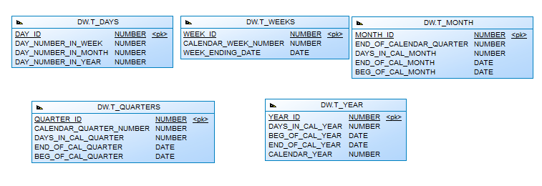

# OLAP – Business analyses task

## Task 06 – Solution concept – Add: Chapter Dimensions Types

**The Main Task** is to create summary table to describe all future STAR Dimensions:

Next points are mandatory:

* Start scheme must use no less one of SCD type 2 Dimension
* Start scheme must use prepared dimensions: DIM_TIME, DIM_GEO_LOCATIONS
* Start scheme must use one of period dimensions: DIM_GEN_PERIODS

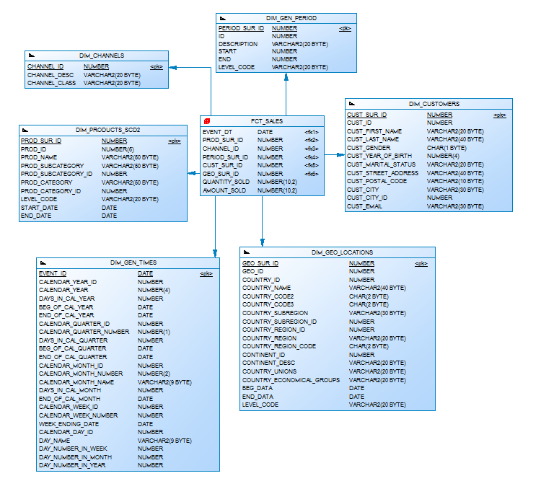

**Task Results:**

Create document, which contained next chapters:

* + Chapter: Dimensions Types Description

|  |  |  |  |  |
| --- | --- | --- | --- | --- |
| Name | Type | Size | DW – Merged Dimensions | Descriptions |
| DIM_GEN_TIMES | SCD1 | BIG | DW.T_DAYS, DW.T_WEEKS, DW.T_MONTHS, DW.T_QUARTERS,  DW.T_YEARS | It is a specific type of dimension. Appears at the DWR and contains all the time since the introduction of the project until its completion. |
| DIM_GEO_LOCATIONS | SCD1 | SMALL | DW.T_COUNTRIES  DW.T_CNTR_GROUPS  DW.T_CNTR_SUB_GROUPS  DW.LC_CNTR_GROUPS  DW.T_GEO_TYPES  DW.T_GEO_SYSTEMS  DW.LC_GEO_SYSTEMS  DW.T_GEO_PARTS  DW.T_GEO_REGIONS  DW.T_GEO_OBJECTS  DW.T_CNTR_GROUP_SYSTEMS  DW. LC_CNTR_GROUP_SYSTEMS  DW.LC_CNTR_SUB_GROUPS  DW.LC_ GEO_PARTS  DW.LC_COUNTRIES  DW.LC_ GEO_REGIONS | This kind of dimension contains information about all countries, subregions, regions of the world. And also enters information on the types of economic development and unions according to the international classification. |
| DIM_CUSTOMERS | SCD1 | BIG | DW.T_CUSTOMERS  DW.T_GENDER  DW.T_MARITAL_STATUS  DW.T_ADDRESS  DW.T_EMAIL | This kind of dimension contains detailed information about clients (including postal code and address of the residence for informative presentation). |
| DIM_PRODUCTS | SCD2 | BIG | DW.T_PRODUCT_DESC  DW.T_PROD_SUBCAT  DW.T_PROD_CAT | This kind of dimension contains detailed information about the company's products, including the name of an individual product, category and subcategory. To do so, provided the opportunity for dimension Type SCD 2 perfectly partitions history because each detailed version of a dimensional entity is correctly connected to the span of fact table records for which that version is exactly correct |
| DIM_CHANNELS | SCD1 | SMALL | DW.T_CHANNEL_DESC  DW.T_CHANNEL_CLASS | Provides information about channels of sales (description and class) |
| DIM_GEN_PERIOD | SCD1 | SMALL | DW.T_PERIOD_DESC  DW.T_PER_START  DW.T_PER_END  DW.T_LEVEL_CODE | Dimension specific type, which allows grouping of facts on the basis of logic (the age of customers). |
|  |  |  |  |  |

## Task 07 – Solution concept – Add: Chapter Dimensions Hierarchies

**The Main Task** is to create summary table to describe all future STAR Dimensions Hierarchies:

Next points are mandatory:

* Start scheme must use no less one of SCD type 2 Dimension
* Start scheme must use prepared dimensions: DIM_TIME, DIM_GEO_LOCATIONS
* Start scheme must use one of period dimensions: DIM_GEN_PERIODS



**Task Results:**

Create document, which contained next chapters:

* + Chapter: Dimensions Hierarchies

**DIM_GEN_TIME:**

**Hierarchy DAY-WEEK-MONTH-YEAR**

|  |  |  |  |
| --- | --- | --- | --- |
| Name | LEVEL_CODE | LEVEL_DESC | LEVEL_NATURAL_KEY |
| DAYs | DAY | Store all day at the calendar | DAY_ID |
| WEEKs | WEEK | Store all weeks at the calendar year | WEEK_ID |
| MONTHs | MONTH | Store all months at the calendar year | MONTH_ID |
| YEARs | YEAR | Store all years at the calendar year | YEAR_ID |
|  |  |  |  |

**Hierarchy DAY--MONTH- QUARTER -YEAR**

|  |  |  |  |
| --- | --- | --- | --- |
| Name | LEVEL_CODE | LEVEL_DESC | LEVEL_NATURAL_KEY |
| DAYs | DAY | Store all day at the calendar year | DAY_ID |
| MONTHSs | MONTH | Store all months at the calendar year | WEEK_ID |
| QUARTERs | QUARTER | Store all quarters at the calendar year | QUARTER_ID |
| YEARs | YEAR | Store all years at the calendar year | YEAR_ID |
|  |  |  |  |

**DIM_PRODUCTS:**

**Hierarchy PRODUCTS –-SUBCATEGORY-- CATEGORY**

|  |  |  |  |
| --- | --- | --- | --- |
| Name | LEVEL_CODE | LEVEL_DESC | LEVEL_NATURAL_KEY |
| PRODUCTS | PROD_NAME | Store all possible products for each category. | PROD_ID |
| SUBCATEGORIES | PROD_SUBCATEGORY | Store all product subcategories for each category. | PROD_SUBCATEGORY_ID |
| CATEGORIES | PROD_CATEGORY | Store all product categories of our company. | PROD_CATEGORY_ID |
|  |  |  |  |

**DIM_GEO LOCATIONS:**

**Hierarchy COUNTRY –-SUBREGION--REGION**

|  |  |  |  |
| --- | --- | --- | --- |
| Name | LEVEL_CODE | LEVEL_DESC | LEVEL_NATURAL_KEY |
| COUNTRIES | COUNTRY_NAME | Store all countries for each region. | COUNTRY_ID |
| SUBREGIONS | COUNTRY_SUBREGION | Store all subregions for each region . | COUNTRY_SUBREGION_ID |
| REGIONS | COUNTRY_REGION | Store all regions of the world. | COUNTRY_REGION_ID |
|  |  |  |  |

## Task 08 – Solution concept – Add: Chapter Facts Aggregations

**The Main Task** is to create summary table to describe all future STAR Fact Table Aggregations:

Next points are mandatory:

* Create more than one measurement
  + Summarize aggregation
  + Additional task: Not Additive measurement

**Task Results:**

Create document, which contained next chapters:

* + Chapter: Facts Aggregations

|  |  |  |  |  |
| --- | --- | --- | --- | --- |
| Name | Code | Table Name | Additive | Descriptions |
| Counts amount sold products | AMOUNT_SOLD | FCT_SALES | + | Calculate distinct values of Sales at the event_dt period. |
| Counts quantity sold products | QUANTITY_SOLD | FCT_SALES | + | Calculate distinct values of Saled Products at the event_dt period. |